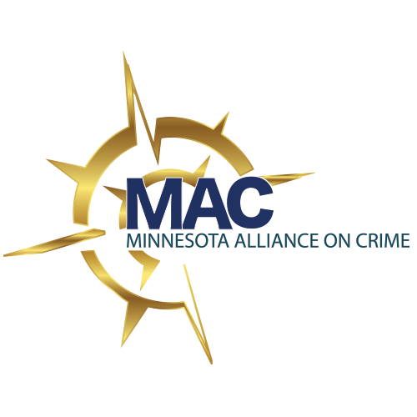
Fiscal Year 2019
(July 1, 2018—June 30, 2019)
Membership Information & Application

One West Water Street, Suite 260 | St. Paul, MN 55107
612.940.8090 | www.mnallianceoncrime.org

About the Minnesota Alliance on Crime
The Minnesota Alliance on Crime is a membership coalition of crime victim service organizations and individuals in Minnesota, including prosecution-based victim/witness programs, community programs, law enforcement agencies, civil legal organizations, and individuals committed to supporting crime victims. We support our membership through training, technical assistance, resources, public policy and legislative initiatives, and networking opportunities.

Mission
The mission of the Minnesota Alliance on Crime (MAC) is to connect systems, service providers, and victim to advance the response for victims of all crime.

Core Values
- We oppose the use of all forms of violence and affirm the basic human right of every person to live without fear or the threat of violence throughout the course of one’s life.
- We seek to ensure a criminal justice system that is fair and accessible to crime victims, and meaningful rights for crime victims are routinely honored.
- We stand in solidarity with efforts around the world to end all forms of discrimination, exploitation and violence.
- We recognize that forms of oppression based on race, gender, class, ethnicity, nationality, disability, age, religion and sexual orientation create a climate of supremacy and ownership that facilitates the use of on-going violence.
- We believe in the strength of diversity, embrace the differences among ourselves and within our communities, and promote the development of leadership in all communities.
- We undertake prevention efforts to confront and change cultural norms and practices that facilitate violence.
- We promote and encourage the leadership of victim/survivors in guiding our advocacy, policy, and training efforts.
- We affirm the power of collective and collaborative efforts to advocate with social systems and institutions in order to end violence.
- We encourage reflection about our work and thoughtful evaluation of our efforts. We are committed to the ongoing development of innovative strategies and programs to better meet the diverse and emerging needs of crime victims.
- We commit to create a work environment for staff and volunteers that respects diversity, fosters professional growth, encourages critical thinking and initiative, and promotes diligent and effective advocacy efforts.

Benefits of MAC Membership

Training and Technical Assistance:
- Participate in MAC trainings at no cost and receive travel, lodging, and meal reimbursement when applicable
- Attend free web trainings, including access to archived trainings
- Attend the MAC Annual Meeting and Capacity Building Training
- Contact MAC staff when you need technical assistance, media relations support, research, or resources

Information and Resource Materials:
- Receive MAC electronic newsletters with news, resources, and funding opportunities
- Utilize the MAC website for information about trainings and events, brochures, articles, and other resources
- Have access to the “members only” section of MAC’s website, which includes special resources and archived training
- Share information and resources with your fellow members at networking meetings and other MAC events

Networking Opportunities:
- Shape the priorities and activities of MAC at the Annual Membership Meeting
- After one year of membership, join the MAC Board of Directors
- Join MAC networks, such as the Training Development Workgroup and the Legislative and Public Policy Committee
- Participate in e-mail discussion lists with colleagues from across the state, including up-to-the-minute news and resources

Public Policy & Legislation:
- MAC members help shape the statewide legislative and policy agenda and participate in emerging issues discussions, needs assessments, surveys, and committee work
- MAC provides member programs with resources to educate decision-makers about the importance of community efforts to end violence and the need to continue to fund the programs that make these community efforts possible
- MAC tracks state and federal legislative activity that impacts programs providing services to crime victims
- MAC provides member programs with ongoing information about legislative events and with tools and guidance for how to be part of a collective voice at the Minnesota Capitol

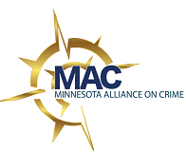
Fiscal Year 2019 Membership Application Form
July 1, 2018 - June 30, 2019

Date of Application: | Is this a new or renewal application? New Renewal
Organization Name:

Contact Person:

Contact E-mail:

Mailing Address:

City: |  | State: | Zip:
Business Phone: |  | Ext:
Business Fax:

Business Web Address:

Name and email addresses of all staff to be added to the MAC Members Listserv: (If renewing membership, only indicate any changes. Please use separate document, if needed.)
Name: Email:
Name: Email:
Name: Email:
Name: Email:
Name: Email:
Name: Email:
Name: Email:
Name: Email:
Name: Email:
Name: Email:
Counties/Area of Service (please describe):
Type of membership requesting:

Two different types of membership are available to organizations. All members benefit from participation in MAC sponsored events, training, and resource dissemination; voting members have additional opportunities to participate in the work of MAC.

Please check either “Voting Member Organization” or “Supportive Non-Voting Organization.”
- Voting Member Organization: Organization that provides direct services to crime victims. Voting members vote on the slate new board members, public policy/legislative initiatives, and changes to MAC by-law.

(All boxes must be checked and voting delegate name must be filled in order to be a voting member)
- Incorporated as a Minnesota non-profit organization or tribal organization; or are a Victim/Witness Program located within a prosecutorial office; or are a law enforcement entity that employs a victim advocate.
- Organization provides criminal justice advocacy, financial assistance, safety planning, and referrals to allied community and government programs.
- Organization supports and promotes the mission statement and core values of MAC.
- Payment for FY19 membership dues is included with this form.
- Organization will support and attend MAC’s Annual Meeting.
Each voting member organization shall appoint one (1) individual to serve as their voting delegate and one (1) individual to serve as their voting alternate at meetings of the membership. These individuals will serve as delegates and alternates until successors are appointed. Replacement delegates and alternates may be appointed by member organizations by providing written notice to MAC before scheduled meetings.

Voting Delegate Name: ________________________________________

Voting Alternate Name: ________________________________________

- Supportive Non-Voting Organization: Nonprofit; health and education; tribal, state, and local government; and other organizations that do not provide direct services to crime victims; and actively promote the mission statement and core values of MAC may join as supportive non-voting members. Direct victim service programs must join as voting members.
- Supportive Non-Voting Individual: Individual, student, or victim/survivor that actively promotes the mission statement and core values of MAC may join as a supportive non-voting member.

Authorized Signature: _____________________________________ Date: __________________

Your membership dues are based on your organization’s current annual operating budget. Please refer to the chart on the following page to determine your dues.

MAC Annual Membership Dues Schedule

If joining MAC after August 1, 2018, FY19 dues will be prorated for new members. Please contact Danielle Kluz at danielle@mnallianceoncrime.org to determine your dues for the current fiscal year.

(For programs that are a sub-group of a larger government agency or non-profit corporation, dues are based on the operating budget of the victim services program only.)

If your annual operating budget is: | Your annual membership dues are:
$0 - $60,000 | $125.00
$60,001 - $100,000 | $150.00
$100,001 - $500,000 | $250.00
$500,001 - $1,000,000 | $350.00
$1,000,001 and over | $450.00
Supportive Non-Voting Organization  (does not provide direct services) | $100.00
Supportive Non-Voting Individual | $50.00
Supportive Non-Voting Student | $25.00
Supportive Non-Voting Victim/Survivor | FREE

Operating budget for current fiscal year: $_____________________________

Membership amount due: $_____________________________

Are you using funds from an OJP grant award to pay for any portion of your membership dues? □ YES □ NO

If you answered yes, what percentage of your dues is made up of OJP grant funds? _____%

Checklist and Membership Agreement (Please check each box)
We have reviewed the following:
- MAC Mission Statement and Core Values
- Membership Benefits

We have included the following with our application:

- Organizational Mission Statement
- A check for $

(Please return pages 5-7 of your completed membership application along with your payment. If you are paying dues via credit card, MAC will add a 5% service fee.)

Mail to: Minnesota Alliance on Crime
Attn: Danielle Kluz
One West Water Street, Suite 260
St. Paul, MN 55107

