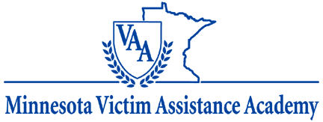

|  |
| --- |
| The Minnesota Office of Justice Programs is currently accepting applications for the 2018 Minnesota Victim Assistance Academy!   The training is tentatively scheduled for October 9-12 & November 14-16, 2018.  The application deadline is August 17, 2018.  The Minnesota Victim Assistance (MNVAA) is a series of comprehensive, academically based trainings to build the capacity of victim assistance providers, victim advocates, criminal justice professionals, law enforcement, and other professionals who work with victims of crime. |

|  |
| --- |
| **Program Overview** Track 1 of the Minnesota Victim Assistance Academy (MNVAA) is a foundation-level educational opportunity.  Offered annually, this week-long intensive course of study is broken into two segments designed to improve the quality and consistency of victim services in Minnesota. Through education, the MNVAA builds the capacity of providers to serve those victimized by crime, encourages cutting-edge thinking about the ways we can help victims regain control of their lives, and focuses on victim-centered multi-disciplinary collaboration building.  Up to 50 candidates will be selected to attend and explore a comprehensive curriculum created specifically for Minnesota by a multidisciplinary committee assembled by the Minnesota Office of Justice Programs. All students who are accepted and successfully complete this 40-hour MNVAA course receive a certificate of completion. Academic credit and CEUs may be available for an additional fee.  **2018 Training Dates**  The 2018 Academy will kick off with a welcome reception/registration on Tuesday, October 9, 2018. Registration opens at 3:30 p.m. and the reception will start at 5:30 p.m.  The classroom instruction will be held October 10, 11 and a half day on October 12th and then again on November 14, 15 and a half day on November 16th, 2018.  The location has yet to be determined as it goes through the State's RFP bidding process, yet will be in the greater metro.    **Application**  Applications for the 2018 Academy will be accepted until August 17, 2018. The fee is $225 and covers room and board, with the exception of dinner each night. Review criteria here.  Please complete the application form and submit it electronically to Joann Jones, MNVAA Director, at [joann.jones@state.mn.us](mailto:joann.jones@state.mn.us). |