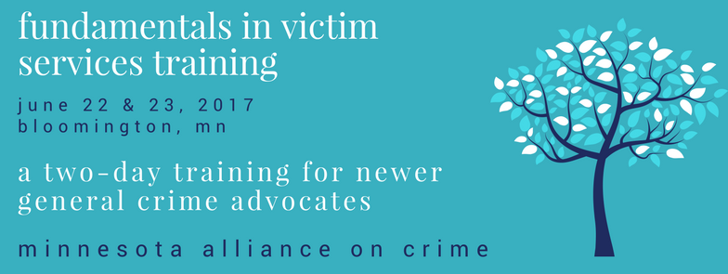
Training Agenda

(Subject to change.)
Day One: June 22
7:30—8:00 am Registration
8:00—8:15 am Welcome and Housekeeping
8:15—8:45 am Survivor Story
8:45 —9:45 am Bias, Privilege and Oppression I—Experiential Exercises
9:45—10:00 am Break
10:00—11:15 am Bias, Privilege and Oppression II—Group Discussion
11:15—12:15 pm Lunch
12:15—2:15pm Core Advocacy I
- History of Crime Victim Rights/Services
        - What Is Advocacy? Why Is It Important?
        - Roles of the Advocate—System and Community Experiential Exercise(s)
2:15—2:30 pm Break
2:30—4:15 pm Core Advocacy II
        - Empathy/Compassion and Active Listening
        - Victim’s Right to Self-Determination
        - Experiential Exercise(s)
4:15—4:20 pm Day One Closing

Day Two: June 23
8:00—8:15 am Welcome and Housekeeping
8:15—10:00 am Advocate Ethics and Conduct
- Scope of Services
        - Coordinating Within the Community
        - Direct Victim Services
        - Privacy, Confidentiality and Data Security
        - Experiential Exercise(s)
10:00—10:15 am Break
10:30—Noon Systems Advocacy
- Changing Systems to Be More Responsive to Victims
        - Advocating for Victim with Prosecution
        - Navigating and Challenging Complex Systems
        - Experiential Exercise(s)
Noon—1:00 pm Lunch
1:00—3:00 pm Victims’ Rights
        - Overview of Minnesota Law
        - How Are Victims Being Made Aware of Their Rights?
        - How Victims’ Rights Play Out in Different Jurisdictions
        - Experiential Exercise(s)
3:00—3:15 pm Break
3:15—4:15 pm Core Advocacy III
        - Effective Community Relationship Building
        - Self-Care and Secondary Trauma
        - Experiential Exercises(s)
4:15—4:30 pm Closing
- Moving Forward After Training
- MAC Resources
- Evaluation

